1. On the diagram of a shoot tip, the structure labeled "a" is a
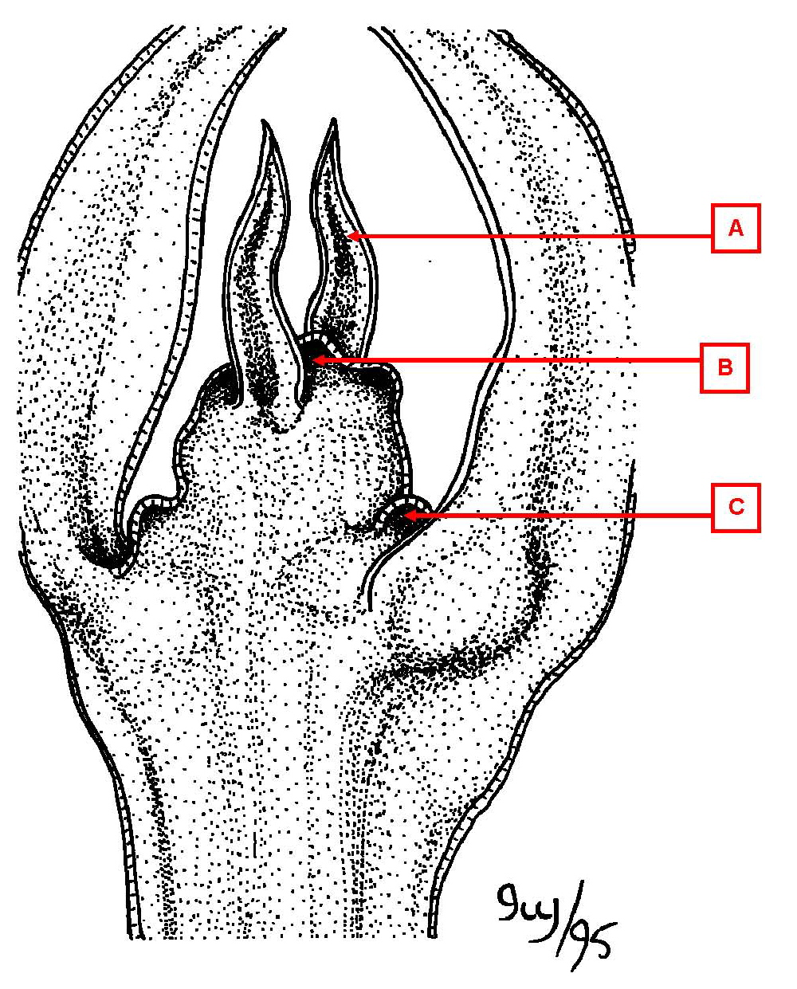

a. apical meristem
b. axillary bud
*c. leaf primordium

2. On the diagram of a shoot tip, the structure labeled "b" is a

*a. apical meristem
b. axillary bud
c. leaf primordium

3. On the diagram of a shoot tip, the structure labeled "c" is a

a. apical meristem
*b. axillary bud
c. leaf primordium

4. On the diagram of a root tip, the structure labeled "a" is a
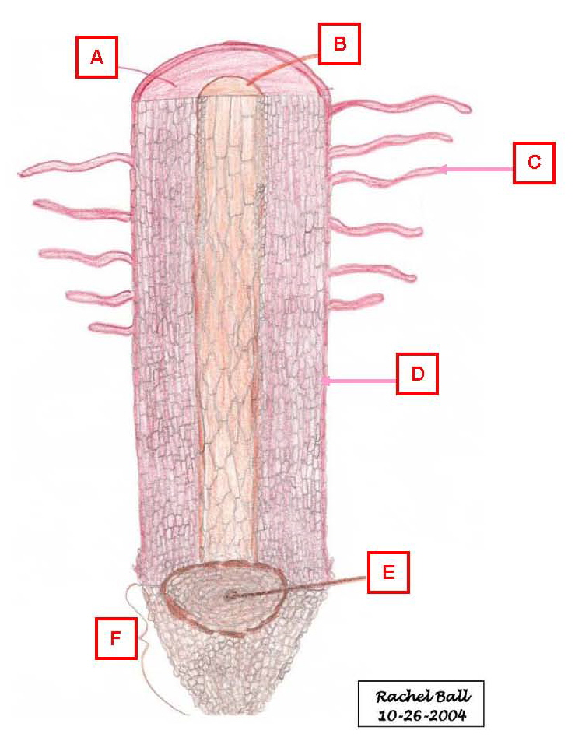

a. apical meristem
*b. cortex
c. epidermis
d. root cap
e. root hair
f. vascular cylinder

5. On the diagram of a root tip, the structure labeled "b" is a

a. apical meristem
b. cortex
c. epidermis
d. root cap
e. root hair
*f. vascular cylinder

6. On the diagram of a root tip, the structure labeled "c" is a

a. apical meristem
b. cortex
c. epidermis
d. root cap
*e. root hair
f. vascular cylinder

7. On the diagram of a root tip, the structure labeled "d" is a

a. apical meristem
b. cortex
*c. epidermis
d. root cap
e. root hair
f. vascular cylinder

8. On the diagram of a root tip, the structure labeled "e" is a

*a. apical meristem
b. cortex
c. epidermis
d. root cap
e. root hair
f. vascular cylinder

9. On the diagram of a root tip, the structure labeled "f" is a

a. apical meristem
b. cortex
c. epidermis
*d. root cap
e. root hair
f. vascular cylinder

10. On the diagram of a dicot root cross section, the structure labeled "a" is a
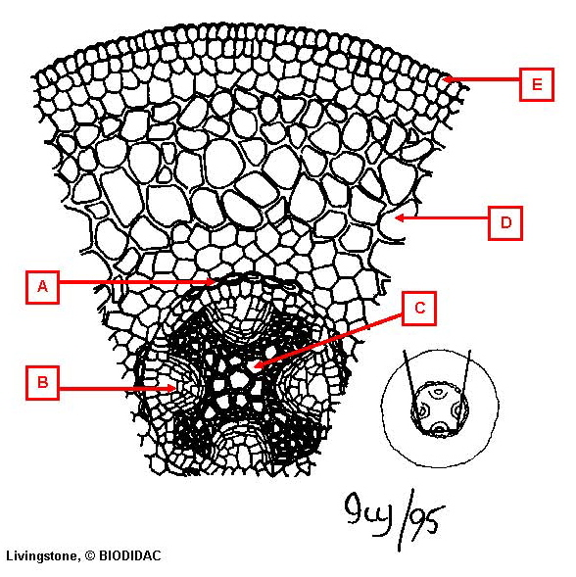

*a. endodermis
b. epidermis
c. cortex
d. phloem
e. xylem

11. On the diagram of a dicot root cross section, the structure labeled "b" is a

a. endodermis
b. epidermis
c. cortex
*d. phloem
e. xylem

12. On the diagram of a dicot root cross section, the structure labeled "c" is a

a. endodermis
b. epidermis
c. cortex
d. phloem
*e. xylem

13. On the diagram of a dicot root cross section, the structure labeled "d" is a

a. endodermis
b. epidermis
*c. cortex
d. phloem
e. xylem

14. On the diagram of a dicot root cross section, the structure labeled "e" is a

a. endodermis
*b. epidermis
c. cortex
d. phloem
e. xylem

15. On the diagram of a dicot stem cross section, the structure labeled "a" is a
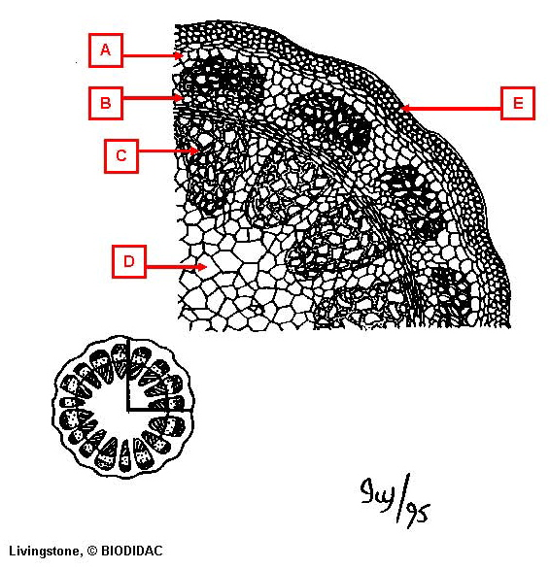

a. epidermis
*b. cortex
c. phloem
d. pith
e. xylem

16. On the diagram of a dicot stem cross section, the structure labeled "b" is a

a. epidermis
b. cortex
*c. phloem
d. pith
e. xylem

17. On the diagram of a dicot stem cross section, the structure labeled "c" is a

a. epidermis
b. cortex
c. phloem
d. pith
*e. xylem

18. On the diagram of a dicot stem cross section, the structure labeled "d" is a

a. epidermis
b. cortex
c. phloem
*d. pith
e. xylem

19. On the diagram of a dicot stem cross section, the structure labeled "e" is a

*a. epidermis
b. cortex
c. phloem
d. pith
e. xylem

20. On the diagram of a dicot leaf, the structure labeled "a" is a
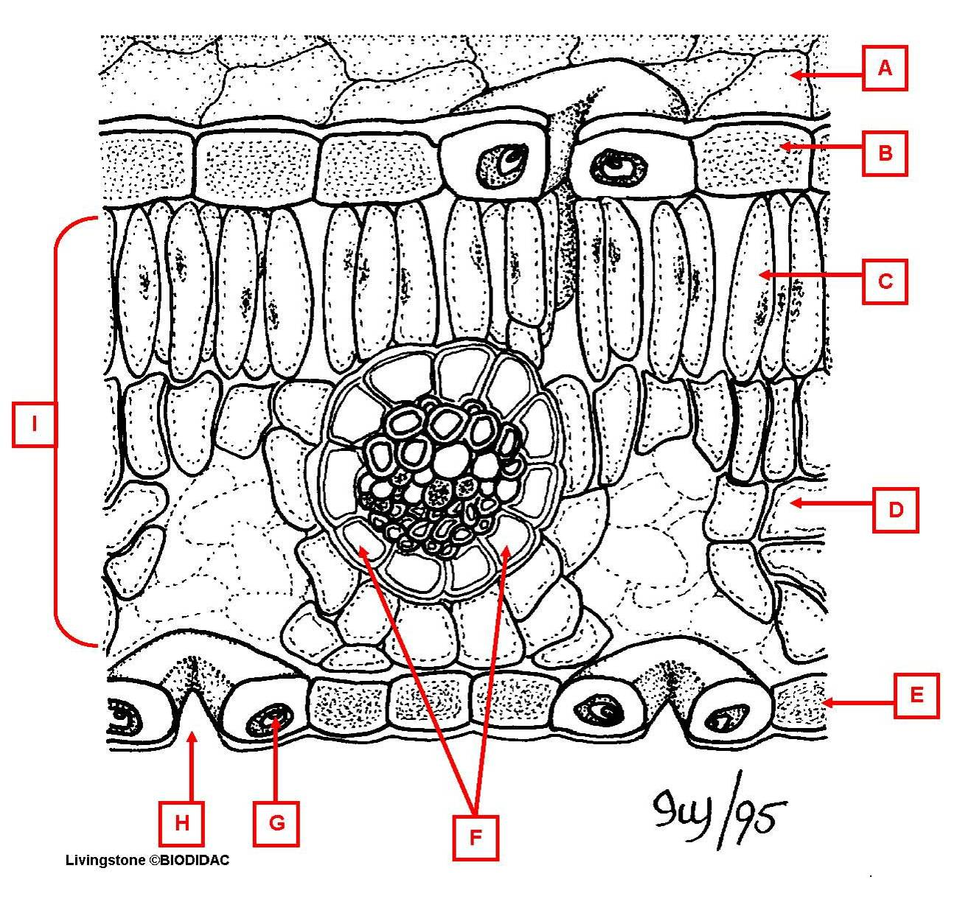

*a. cuticle
b. guard cell
c. lower epidermis
d. mesophyll
e. palisade parenchyma
f. spongy parenchyma
g. stoma
h. upper epidermis
i. vein

21. On the diagram of a dicot leaf, the structure labeled "b" is a

a. cuticle
b. guard cell
c. lower epidermis
d. mesophyll
e. palisade parenchyma
f. spongy parenchyma
g. stoma
*h. upper epidermis
i. vein

22. On the diagram of a dicot leaf, the structure labeled "c" is a

a. cuticle
b. guard cell
c. lower epidermis
d. mesophyll
*e. palisade parenchyma
f. spongy parenchyma
g. stoma
h. upper epidermis
i. vein

24. On the diagram of a dicot leaf, the structure labeled "d" is a

a. cuticle
b. guard cell
c. lower epidermis
d. mesophyll
e. palisade parenchyma
*f. spongy parenchyma
g. stoma
h. upper epidermis
i. vein

25. On the diagram of a dicot leaf, the structure labeled "e" is a

a. cuticle
b. guard cell
*c. lower epidermis
d. mesophyll
e. palisade parenchyma
f. spongy parenchyma
g. stoma
h. upper epidermis
i. vein

26. On the diagram of a dicot leaf, the structure labeled "f" is a

a. cuticle
b. guard cell
c. lower epidermis
d. mesophyll
e. palisade parenchyma
f. spongy parenchyma
g. stoma
h. upper epidermis
*i. vein

27. On the diagram of a dicot leaf, the structure labeled "g" is a

a. cuticle
*b. guard cell
c. lower epidermis
d. mesophyll
e. palisade parenchyma
f. spongy parenchyma
g. stoma
h. upper epidermis
i. vein

28. On the diagram of a dicot leaf, the structure labeled "h" is a

a. cuticle
b. guard cell
c. lower epidermis
d. mesophyll
e. palisade parenchyma
f. spongy parenchyma
*g. stoma
h. upper epidermis
i. vein

29. On the diagram of a dicot leaf, the structure labeled "i" is a

a. cuticle
b. guard cell
c. lower epidermis
*d. mesophyll
e. palisade parenchyma
f. spongy parenchyma
g. stoma
h. upper epidermis
i. vein

